Instruments and Ranges
Clarinet / bass clarinet

Clarinet in B-flat (sounding)

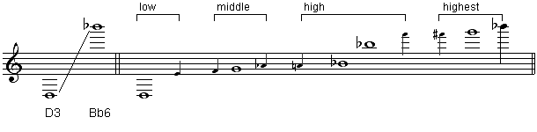

Clarinet in B-flat (written)
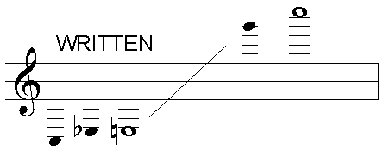
Bass Clarinet (sounding)

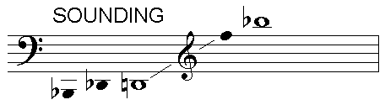
Bass Clarinet (written)
Term | Notation in score | What it means
Trills | tr | Alternate quickly between two notes
Slap tongue | S.T. or slap tongue | Tongue hits the reed – quite a percussive noise
Glissando | gliss. or a short line | This can be done in two ways – with the mouth and through sliding on or off keys. It tends to have a small range (semi-tone), be easier high up and work best sliding upwards.
Air tones | breathy or air sound | Where no note is sounded. This effect is very quiet.
Growl/flutter tongue | Growl or three lines on the stem, same as trem. | This must be done in the back of the throat

Soprano
Term | Notation in score | What it means
Melisma |  | Sharing a vowel sound across several pitches
Syllabic |  | Each note has a different word/syllable on it
Covering mouth | Cover mouth | Muffles the sound
Glissando | gliss. or a short line | Slide between notes
Consonant sounds | Write the consonant | Noises can be made: “shh”, “ckr”, “mm”, “ah”, “wah” etc
Speaking | spoken | Write words in the score, these can be given an unpitched rhythm, or if completely spoken, just written as prose.
Note: Vocal dynamics go above the music, so as to leave room for the lyrics beneath. Dynamics on the harp can go between the staves if they can fit, and below to be specific to the lower part. Dynamics in all other instruments go beneath the stave.

Double Bass

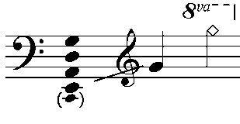

Term | Abbreviation in the score | What it means
Arco | arco | Play using the bow
Pizzicato | pizz | Pluck the strings
Slur | ͡ or ͜ | Do not change bow
Col Legno | col leg. (c.l.) | With the wood of the bow
Sul ponticello | sul pont. (s.p.) | Near the bridge
Sul tasto | sul tasto (s.t.) | Near the fingerboard (normally understood as ‘on’ the fingerboard)
Tremolo | trem. | Fast unmeasured bow changes
Legato | legato | Smooth and without silence between notes
Spiccato | spicc. | Bow leaves the string to produce a light bouncing sound
Jeté/Ricochet | Jeté | Bow is ‘thrown’ at the string to produce a rapid series of notes, normally unspecified and unmeasured
Bartok/snap Pizzicato | a circle with a line | String is pulled away from the fingerboard, so that it snaps against in on release
Left hand pizz | L.H. pizz or + | String plucked with LH, best with open strings

Harp
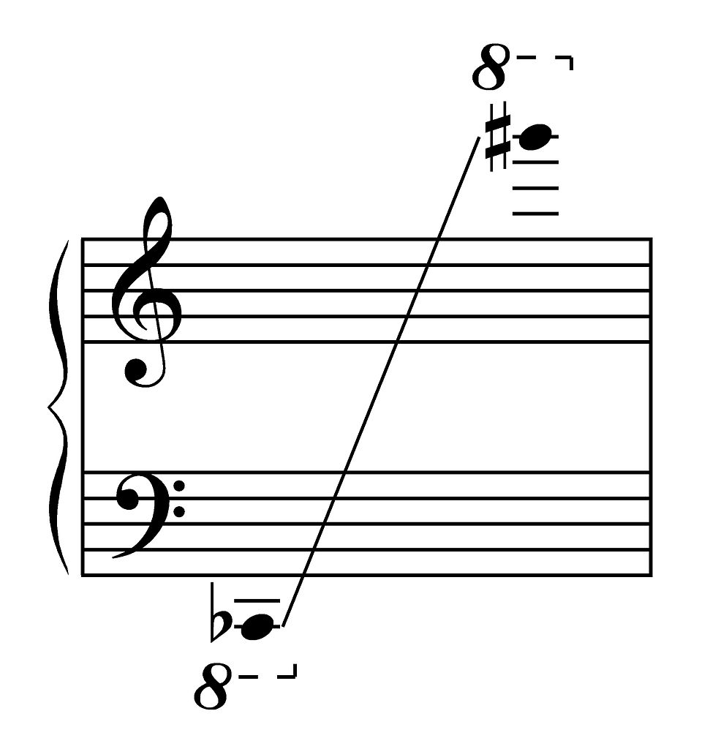

Listening List
This instrumentation has not been regularly used; however there are a number of good examples of pieces with similar instrumentation, or solo pieces for the instruments from the ensemble.
Pre-1950s
Maurice Ravel Introduction and Allegro Harp, flute, clarinet and string quartet
Claude Debussy Sonata Harp, flute and viola
Igor Stravinsky Three pieces Solo clarinet
Post 1950s
Benjamin Britten Suite for Harp Solo harp
Sofia Gubaidulina Garden of Joy and Sorrow Harp, flute and viola
Luciano Berio Sequenza II Solo harp
Luciano Berio Sequenza III Solo voice
Björk Medula Voices
Harrison Birtwistle 9 Celan Settings Soprano, 2 clarinets, viola, cello, bass
Hermes Experiment
Recordings of a range of music for harp, clarinet, double bass and soprano can be found on the website of the Hermes Experiment – an ensemble that uses this instrumentation. The group will be performing the entries at the Finals of the Cambridge Young Composer of the Year Competition on 30 October 2016, at West Road Concert Hall:
www.thehermesexperiment.com/music

