Instruments and Ranges
Flute
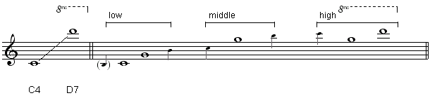
Piccolo (sounding)
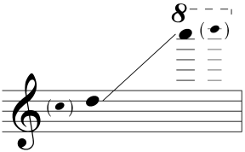
Piccolo (written)
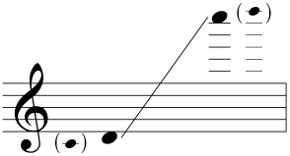

Clarinet in B-flat (sounding)
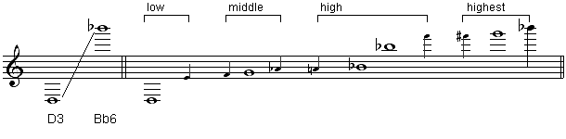

Clarinet in B-flat (written)
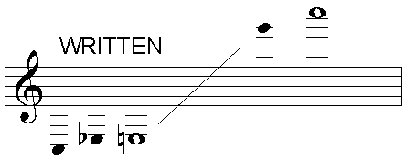
Bass Clarinet (sounding)

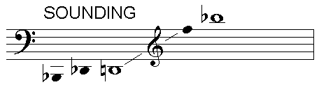
Bass Clarinet (written)

Violin
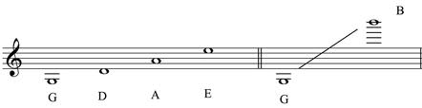
Cello
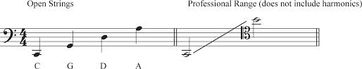

Percussion

Vibraphone
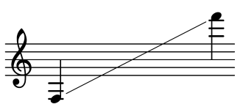

Glockenspiel (sounds two octaves higher)
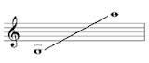
Un-tuned Percussion notation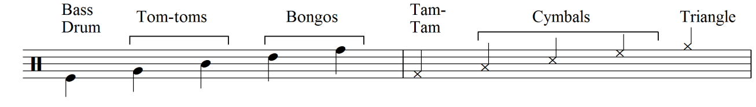
Listening List
This instrumentation has been incredibly popular in the contemporary music during the second half of the 20th century. There are also two important examples from before 1950, which had a strong influence on the music that came after.

Pre-1950s
Arnold Schoenberg - Pierrot Lunaire
First piece to be written for a similar line-up of instruments (fl.cl.vn.vc.pno.soprano)
Olivier Messiaen – Quatuor pour le fin du temps (Quartet for the End of Time)
Written during WW2 in a concentration camp (cl.vn.vc.pno)

Post 1950s
Peter Maxwell-Davies – Eight Songs for a Mad Kings (+ Baritone)
Jacob Druckman – Come Round
Morton Feldman – Music for Frank O Hara
Gerard Grisey – Vortex Temporum (+ viola)
Steve Reich – Double Sextet
Salvatore Sciarrino – Lo Spazio Inverso
Pierre Boulez – Derive
Elliot Carter – Triple Duo
Franco Donatoni - Arpège

